Appendix A

*Figure 1*. Schematic illustration of the two types of trials during the acquisition phase of Experiment 1. During the first half of the trial (*left*) the neutral target and two source stimuli were presented in white. During the second half of the trial (*right*) the target and one of the sources changed to the same color whereas the second source stimulus changed to a different color.

**HELL**

**STRUAN**

**SMILE**

**CANCER**

**MORAG**

**JOY**

**CANCER**

**MORAG**

**JOY**

**HELL**

**STRUAN**

**SMILE**

*Figure 2*. Schematic illustration of the two types of trials during the acquisition phase of Experiments 2-3. During the first half of the trial (*left*) the neutral target and two source stimuli were presented in the same color. During the second half of the trial (*right*) the target and one of the sources remained the same color whereas the second source changed to a different color.

**HELL**

**STRUAN**

**SMILE**

**CANCER**

**MORAG**

**JOY**

**CANCER**

**MORAG**

**JOY**

**HELL**

**STRUAN**

**SMILE**

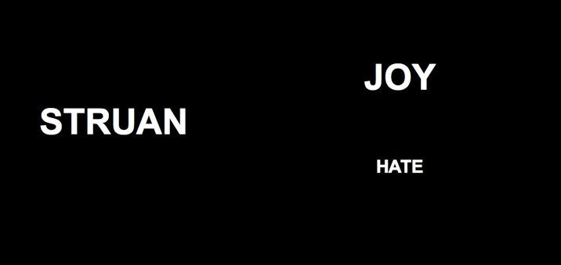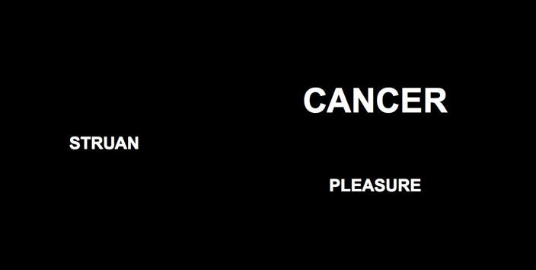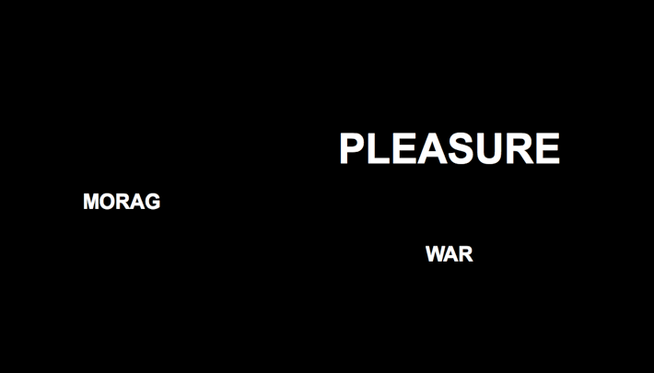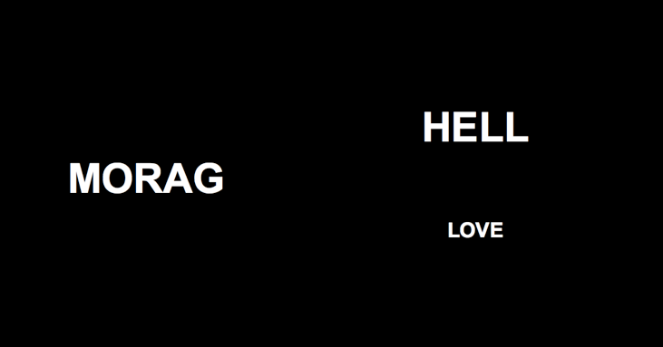

*Figure 3*. Schematic illustration of the two types of trials during the acquisition phase of Experiment 4. During one type of trial (*left*) a neutral target and negative sources were presented in the same size (sometimes in large and other times in small font). During a second type of trial (*right*) another target and positive sources were presented in the same size.

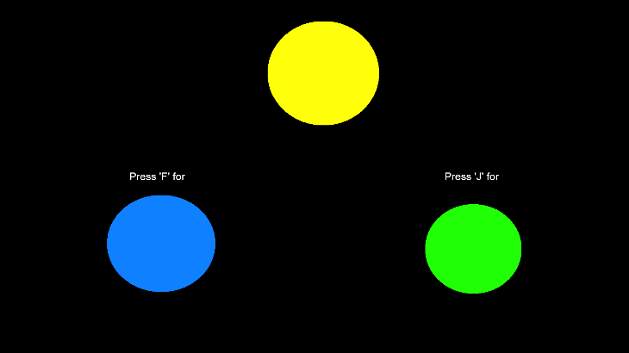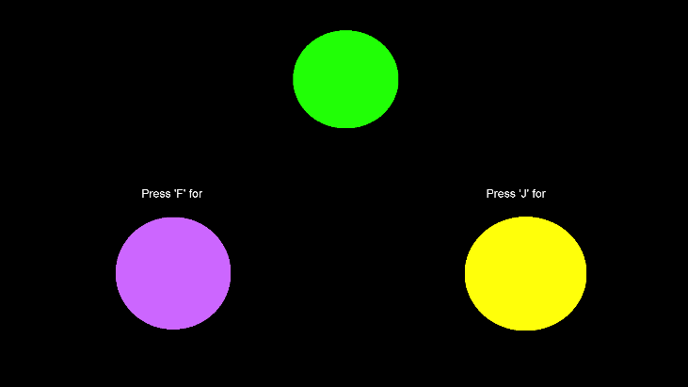

*Figure 4*. Schematic illustration of the two types of trials during the color training phase of Experiment 5. Selecting blue in the presence of yellow, or purple in the presence of green (and vice-versa) was reinforced and any other color relation punished.

*Figure 5*. Schematic illustration of the two types of trials during the acquisition phase of Experiment 5. During one type of trial (*left*) a neutral target and positive sources were presented in colors that had previously been symbolically matched. During a second type of trial (*right*) a second target and negative sources were presented in colors that had also been symbolically matched during the color training phase.

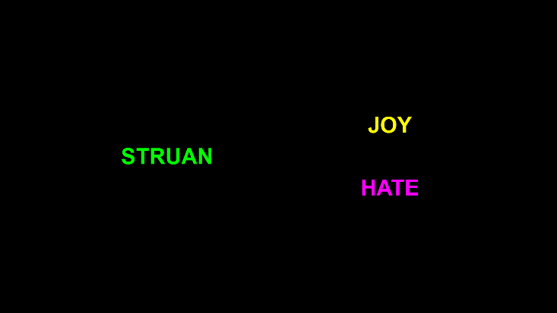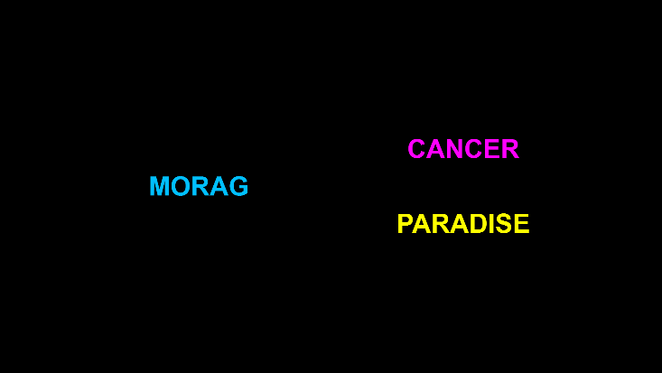

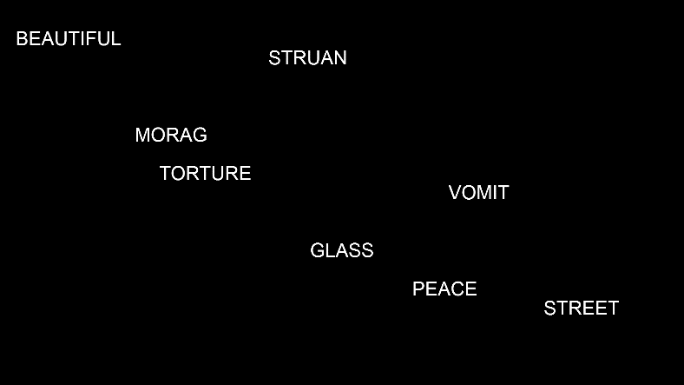

**MORAG**

**PEACE**

*Figure 6*. Schematic illustration of the trial progression during the acquisition phase of Experiment 6. During the first half of the trial (*left*) all eight stimuli (two positive sources, two negative sources, two neutral sources, and two neutral targets) were presented in the same color. During the second half of the trial (*right*) one of the targets (‘Morag’) and a positive source (‘Peace’) changed to a similar color.



*Figure 7*. Distribution of automatic (upper panels) and self-reported (lower panels) evaluations for those in Experiment 2.

*Table 1*. Percentage of sample who were source valence aware, target-source contingency aware, demand compliant, and reactant in each experiment.

|  |  |  | **Demand compliant** | | **Reactant** | |
| --- | --- | --- | --- | --- | --- | --- |
| **Experiment** | **Source valence aware** | **Target-source contingency aware** | **IAT** | **Self-report** | **IAT** | **Self-report** |
| 1 | 65.0 | 71.8 | 17.5 | 15.5 | 19.4 | 16.5 |
| 2 | 65.0 | 62.1 | 14.6 | 11.7 | 9.7 | 15.5 |
| 3 | 79.4 | 79.4 | 18.6 | 22.7 | 11.3 | 14.4 |
| 4 | 78.1 | 62.0 | 7.5 | 17.6 | 9.6 | 15.0 |
| 5 | 74.9 | 45.3 | 14.0 | 19.6 | 8.4 | 15.1 |
| 6 |  |  | 1.7 | 8.2 | 7.4 | 15.2 |
| 7 | 78.1 | 56.8 | 7.0 | 14.1 | 10.5 | 10.0 |
| 8 | 94.9 |  | 1.4 | 13.0 | 10.9 | 22.5 |

*Table 2*. Moderation of shared feature effects as a function of source valence awareness, target-source contingency awareness, hypothesis awareness, reactance, and demand compliance.

|  |  |  |  |  |  |  |  |
| --- | --- | --- | --- | --- | --- | --- | --- |
|  |  | Subset included in the robustness tests | | Subset excluded from the robustness tests | | Difference between subsets | |
| DV | Moderator | *n* | Effect size | *n* | Effect size | χ2 | *p* |
| *IAT* | |  |  |  |  |  |  |
|  | Source valence awareness | 484 | *d* = 0.83 [0.54, 1.12] | 149 | *d* = 0.85 [0.15, 1.54] | 0.01 | .933 |
|  | Target source contingency awareness | 348 | *d* = 1.11 [0.46, 1.77] | 218 | *d* = 0.33 [-1.54, 2.2] | 1.59 | .207 |
|  | Demand compliance | 854 | *d* = 0.8 [0.46, 1.13] | 75 | *d* = 0.76 [-0.16, 1.69] | 0.01 | .913 |
|  | Reactance | 839 | *d* = 0.85 [0.67, 1.04] | 96 | *d* = 0.83 [0.13, 1.52] | 0.01 | .911 |
| *Self-reported evaluations* | |  |  |  |  |  |  |
|  | Source valence awareness | 865 | *d* = 1.19 [1.02, 1.37] | 256 | *d* = 1.29 [0.8, 1.77] | 0.36 | .546 |
|  | Target source contingency awareness | 625 | *d* = 1.8 [1.21, 2.4] | 429 | *d* = 0.34 [-1.43, 2.11] | 5.98 | .014 |
|  | Demand compliance | 1211 | *d* = 1.05 [0.79, 1.3] | 212 | *d* = 1.8 [1.18, 2.43] | 16.34 | < .001 |
|  | Reactance | 1222 | *d* = 1.19 [0.94, 1.44] | 201 | *d* = 0.92 [0.33, 1.51] | 2.44 | .118 |
| *Behavioural intentions* | |  |  |  |  |  |  |
|  | Source valence awareness | 805 | OR = 1.89 [1.47, 2.32] | 249 | OR = 0.96 [-0.25, 2.18] | 5.29 | .021 |
|  | Target source contingency awareness | 625 | OR = 2.88 [1.95, 3.82] | 429 | OR = 0.03 [-2.64, 2.69] | 10.47 | .001 |
| *Notes:* Subset employed in the robustness tests = results calculated using the subset of participants that was included in the robustness tests (i.e., those who were source-valence *aware*, target-source contingency *aware*, demand *non-compliant*, and *non-reactant*); Subset excluded from the robustness tests = results calculated using the subset of participants that was excluded for the robustness tests (i.e., those who were source-valence *unaware*, target-source contingency *unaware*, demand *compliant*, and *reactant*); Effect size = meta analytic effect size in that subset with 95% confidence intervals; χ2 = chi-squared test for moderation (*df* = 1 for all tests). | | | | | | | |